**“One-third for the birds," marine mammals and fish?**

**Forage thresholds for productivity of marine vertebrate predators**

Julie A. Thayer, William J. Sydeman

Farallon Institute, 101 H St., Ste Q, Petaluma, CA, 94952, USA

Contact: Julie Thayer, phone 707-981-8033, email jthayer@faralloninstitute.org.

**Abstract**

Ecosystem-based management of lower trophic level fisheries requires information on the needs of ecologically-dependent predators. We developed a set of empirical models to test the hypothesis of general relationships between prey abundance and predator productivity across marine vertebrate classes. Numerical response models for piscivorous seabirds, fish, and mammals in the California Current Ecosystem (CCE) revealed general shapes of the predator-prey relationships and threshold ranging from 25-33% of the maximum long-term abundance of schooling midwater forage nekton (coastal pelagic fishes, squid, or age-0 piscivorous fishes) to maintain productivity. This supports the previously proposed global rule of “one-third for the birds” (Cury *et al.* 2011) as applying to other marine vertebrate predators. Predators in the CCE showed similar non-linear responses to prey depletion regardless of prey type, predator class, or region (southern or central CCE). This study thus provides an ecosystem-wide indicator for the minimal forage needed to sustain upper trophic level productivity.

*Keywords*: forage fish, prey threshold, prey abundance, predator numerical response, productivity, predator needs, ecosystem-based fisheries management, *Sardinops sagax, Engraulis mordax, Doryteuthis opalescens, Sebastes spp.*

**Introduction**

Predator-prey dynamics have long been emphasized in multispecies fisheries management (May et al*.* 1979, Yodzis 1994). Recently, with the global decline of many marine top predator populations and a growing emphasis on ecosystem-based management, potential competition between human fisheries and marine predators dependent on lower trophic level forage fish has received considerable attention (Pikitch et al*.* 2004). Unfortunately, the impacts of forage fish fisheries, which may account for ~30% of marine fishery landings globally (Alder et al*.* 2008) is still poorly understood, despite many efforts to synthesize available data in complex models (Smith et al*.* 2011, Pikitch et al*.* 2014).

Understanding the thresholds at which prey limit predator productivity is hampered by lack of robust and detailed information on functional and numerical responses. While it is clear that most functional and numerical responses are non-linear (Holling 1959), the form of relationships, and how relationships vary across taxa and space relative to different prey species remains largely unstudied (Hunsicker et al*.* 2011, Link 2010). As one of the first studies to look for general forms of the numerical response, the meta-analysis of Cury et al*.* (2011) demonstrated that the breeding success - prey abundance relationship of seabirds globally follows a Type II curve (*sensu* Holling 1959). Moreover, Cury et al*.* (2011) demonstrated that a prey threshold of approximately one-third of maximum prey biomass was required to maintain high breeding success for 14 species of seabirds across seven marine ecosystems. This threshold provides a potential benchmark for forage fish fisheries management, but it is unknown if it can be generalized across all seabirds, let alone other classes of marine vertebrates that also utilize similar prey species. While there is some evidence that marine mammals and predatory fishes share the same general form of the relationship and threshold established by Cury et al*.* (Boyd and Murray 2001, Boyd 2002, Hunsicker et al*.* 2011), a formal test of this idea has yet to be fulfilled.

Forage fish fisheries are prevalent in eastern boundary upwelling systems of the world (the California, Humboldt, Canary, and Benguela systems; Sydeman et al. 2014), and they are thought to have a variety of negative effects on marine predator foraging and demography (e.g., Kirkman 2009). In contrast to some upwelling systems, notably the Peru system (Cury et al*.* 2000), the CCE is not characterized by “wasp-waist” food web dynamics (Miller et al*.* 2010). Energy transfer occurs via many mid trophic level prey species (Szoboszlai et al*.* 2015), enhancing food web complexity, as well as complexity in numerical responses due to the potential for prey switching. The upper trophic level predator community in the CCE consists of more than ~155 species including >50 seabirds, >30 marine mammals, and >75 predatory fish species. Forage species in this ecosystem consist of coastal pelagic fish including northern anchovy (*Engraulis mordax*) and Pacific sardine (*Sardinops sagax*), juvenile (age-0) predatory fish such as rockfishes (*Sebastes* spp.), as well as invertebrates such as market squid (*Doryteuthis opalescens*). Here, building upon the conceptual approach of Cury et al*.* (2011) and others, we test the hypothesis that numerical response curves and prey thresholds are similar across seabirds and other classes of marine predators in the CCE. To test this hypothesis, we modeled time series of predator demographic traits against contemporaneous information on forage nekton abundance across this ecosystem in two regions. This study is significant because thresholds of response for fish and marine mammals have yet to be compared to those established for seabirds to ascertain if the benchmark for fisheries management is applicable across classes of predators in marine ecosystems.

**Methods**

Data for predator-prey relationships in the CCE were obtained from various publications, technical reports and online databases and supplemented with unpublished data (see Szoboszlai et al. 2015; Table A1, A2). Seabirds in the central CCE included common murre (*Uria aalge*), rhinoceros auklet (*Cerorhinca monocerata*), Brandt’s cormorant (*Phalacrocorax pencillatus*), pelagic cormorant (*P. pelagicus*), and pigeon guillemot (*Cepphus columba*), which bred on offshore Southeast Farallon Island (SFI), nearshore Año Nuevo Island (ANI), and/or Alcatraz Island (ALZ) (Fig. 1; Sydeman et al. 2001, Saenz et al*.* 2006, Thayer and Sydeman 2007, Garcia-Reyes et al. 2013, Carle et al*.* 2014, Leising et al*.* 2014, Elliott et al*.* 2015, J. Thayer unpublished data). Brown pelicans (*Pelecanus occidentalis*)bred at Anacapa (ANA) and Santa Barbara Islands (SBI) in the southern California Bight, and least terns (*Sternula antillarum browni*) at Venice Beach (VB) (Fig. 1). We used time series on seabird breeding success, defined as the number of chicks produced per breeding female (1975-present; Table A2). Pelican data prior to 1975 were not used to avoid confounding effects of DDT on breeding success (Sydeman et al. 2001).

Mammal data included California sea lion (*Zalophus californianus*) pup production at four rookeries, San Clemente (SCI), Santa Barbara (SBI), San Miguel (SMI) and San Nicolas Islands (SNI), in the southern CCE (Table A2, Fig. 1; Lowry and Maravilla-Chavez 2005, Melin et al. 2012, Caretta et al*.* 2014). Predatory fish data included Chinook salmon (*Oncorhynchus tshawytscha*)survival for the California Central Valley (CV) stock which enter the ocean just north of San Francisco (1980-2006; Table A2, Fig. 1, Kilduff et al*.* 2014).

Observation error of marine mammals versus seabirds and salmon is hard to quantify, but the methods for collecting data on each taxon are rigorous and documented and observer error is taken into account. Methods for ensuring data quality included long-time observers; multiple observers, repeated counts and repeated site visits to cross-check data; clear methods and definitions, large sample sizes, limiting counts to good environmental conditions, using photos that can be marked and revisited, and in analysis, excluding data from years that quality may be questionable (Ainley et al. 1990, Sydeman et al. 2001, Lowry and Maravilla 2005, Melin et al. 2012, Kilduff et al. 2014).

Diets of each predator were examined to determine main prey items (Szoboszlai et al. 2015; Table A1). These included four major types: commercial forage nekton species sardine, anchovy, and market squid, as well as juveniles of the rockfish genus (*Sebastes* spp.), primarily shortbelly (*S. jordani*) and widow rockfish (*S. entomelas*).

Concurrent time series on forage fish abundance, expressed as biomass and/or CPUE, were available for the period 1951-2011 in the southern CCE and starting in 1983 (rockfish) in the central CCE (Smith and Moser 2003, Koslow and Allen 2011, Ralston et al*.* 2015, MacCall et al*.* 2015). The National Marine Fisheries Service conducts spring/summer surveys of age-0 and larval fish abundance data from the California Cooperative Oceanic and Fisheries Investigations (CalCOFI) surveys off southern to central California and the Rockfish Recruitment and Ecosystem Assessment Survey off the central California coast (Fig. 1) were used to develop indices of abundance for individual species (market squid, sardine, anchovy) or groups of species (i.e., juvenile rockfish).

Ichthyoplankton data were obtained from night time CalCOFI sampling (<http://www.calcofi.org/new.data/index.php/zooplankton>) and details of sample coverage by cruise are available from http://www.calcofi. org/catlist/232-coverage.html. Detailed descriptions of gear and sampling procedures are given in Kramer et al. (1972), Smith and Richardson (1977), and Moser et al. (1993). Because the temporal coverage of early portions of the time series is monthly and the latter portion quarterly, we used spring seasonal mean abundance.  To remove spatial bias of the sampling regime, we mapped ichthyoplankton abundance data for each cruise to a 10x10 km grid and used linear interpolation to fill in coverage gaps, and then calculated the cruise mean abundance of all grid elements (ind. 10 m-2 of ocean surface), resulting in geo-spatially weighted averages

The Ecosystem Assessment Survey over the continental shelf and slope also collected marine fauna at night with ~15 minute tows of a modified Cobb midwater trawl with a mouth area of ~144 m2 and a variable mesh terminating with a cod end liner mesh of 9.5 mm (Ralston *et al.*, 2015).  The trawl was fished at ~2 knots at a station-specific standard depth (headrope at ~10 m or ~30 m).  Non-standard tows, tows made to non-standard depths, and tows for which an error was noted were not used.  Trawls made in August or later were excluded for seasonal consistency.  A single large catch of 101,300 juvenile rockfishes (98% shortbelly rockfish, *Sebastes jordani*) near Pt. Pinos in 1988 was excluded as an outlier, and set to the next largest value at that station (2,804 rockfishes in 2013).

Data from some of the time series were not normal; a 4th root transformation was identified as best and used for to correct these for normality. To enable robust comparisons across species, classes and regions with different scales of response, time series were scaled to unit mean and expressed as standard deviations. Data were also examined for time trends, then detrended by taking the residuals from quadratic regressions (CITATION FOR QUADRATIC).

Numerical response models were constructed for time series with a minimum of 11 years of concurrent predator and prey data (see supplemental material of Cury et al*.* 2011 for justification). Sardine data were modeled with predator productivity only for years after sardine were no longer “ecologically extinct” in the system (Sydeman et al. 2001), as measured by the first time sardine showed up consistently in predator diets during the timeseries (i.e., 1991-1992; e.g., Thayer and Sydeman 2007, Lowry and Carretta 1999). We used Generalized Additive Models (GAMs) to determine predator-prey relationships since this nonparametric approach makes no *a priori* assumptions about the form of the functional relationships. Models utilized a Gaussian distribution and identity link and smooth functions were estimated with penalized regression splines as implemented in R package mgcv (Wood 2008).  We limited GAM smoothing (effective degrees of freedom = 3) to prevent model over-fitting and to correspond to a biologically realistic set of forcing-response relationships (linear, dome-shaped, sigmoidal).  To quantify thresholds, a change-point analysis was performed on the predicted GAM values (sequential t-tests that find the most likely point at which the slope of predator productivity changes in relation to prey abundance; Cury et al*.* 2011). A bootstrap analysis was used to calculate confidence intervals of the threshold (Cury et al. 2011). Variance in predator productivity was calculated for each prey abundance grouping (every 0.5 from -1.5 to 1.5 standard deviations in prey abundance; there were too few data points above and below these bounds). An F-test was used to test for significant differences in variance from low to high levels of prey abundance.

Models were generated for each predator-prey combination and then combined further since all functional relationships followed a Type II pattern (Table A2, Fig. A1). Models were constructed for 1) each main predator taxa (seabirds, marine mammals, or large fish) and all prey combined, 2) all predators with each separate prey type, and 3) all predators and all prey types combined by region, to elucidate patterns among approaches. Ultimately, we included data for nine predator species representing 17 time series from ten sites within the southern and central regions of the CCE (Table A2) which consumed the four focal prey types listed above (626 data points between 1975 and 2013). Some additional datasets were excluded due to inadequate overlapping predator and prey data points. We did not include predator indices other than “productivity” (e.g., predator foraging effort, foraging success) or data that were modeled rather than observed (e.g., hake and albacore recruitment; Table A3, Fig. A2).

**Results**

Across marine vertebrate classes, a threshold of 24-33% of the maximum long-term prey abundance was needed to sustain high productivity across predator taxa and ecological regions of the CCE (Table 1). This general threshold held for all seabird, marine mammal, and fish predators (individual thresholds of 29%, 24%, and 33%, respectively; Fig. 2) across all prey groups (anchovy, 24%; sardine, 33%; juvenile rockfish, 27%; and market squid, 25%; Fig. 3). Models followed a Type II numerical response curve (Figs. 2, 3, 4; also see Fig. A1). Results were similar by region, with a 25% prey threshold for predators in the southern CCE and a 29% threshold in the central CCE (Fig. 4). Overall, all CCE predators combined exhibited a threshold of 29% of maximum prey abundance (Table 1, Fig. 5a). Variance in predator productivity increased significantly below the prey threshold (p < 0.001; Fig. 5b).

While numerical response models exhibited thresholds of 24-33% of the maximum prey abundance, the normalized threshold values for each model varied between -1/4 and -3/4 standard deviation (s.d.) below the mean prey abundance. The s.d. of the threshold value was -1/4 to -1/3 s.d. for small pelagic schooling fishes anchovy and sardine, while it was double this for invertebrate prey market squid, and more than -3/4 s.d. for juveniles of demersal rockfishes (Fig. 1). For sardine, confidence intervals around the threshold included the mean prey abundance, but for other prey, both the threshold and the upper confidence interval were below the mean.

**Discussion**

Across marine vertebrate predator classes in the CCE, productivity exhibited an asymptotic relationship with abundance of forage, and declined significantly when prey abundance fell below one-quarter to one-third of the maximum value (often referred to as Bmax in fisheries stock assessment models, Hilborn and Walters 1992). This updated form of the predator-prey relationship has been previously observed for seabirds in the CCE (Field et al. 2010, Cury et al. 2011). The threshold of prey depletion where productivity began to decline was remarkably similar to the “one-third for the birds” threshold derived by Cury et al*.* (2011), but here we expanded analyses to include marine mammals and predatory fish.

While Cury et al. (2011) used three CCE seabird datasets (productivity of common murre, pigeon guillemot and rhinoceros auklet in central California in relation to juvenile rockfish abundance), this study included many other predator and prey taxa (nine additional seabird time series, five additional fish/marine mammal time series, and three additional prey types), both from central and southern California. Our results appear to corroborate limited evidence from other ecosystems that marine mammals and predatory fishes share the same general form of the relationship with forage species as do seabirds (Boyd and Murray2001, Boyd 2002, Hunsicker et al*.* 2011). Notably, these predators span a range of life-history strategies, foraging ranges, foraging tactics, and gape-size limitations.

Punt et al. (2016) showed the prey threshold of brown pelicans in the CCE to be much lower than the thresholds we observed, at 10% of Bmax. That study, however, utilized abundance of two prey species, anchovy and sardine, combined additively. The real structure of complex interactions (e.g., multiple forage species, predators with multiple prey, effects of multiple predators), however, is not clear; thus more investigation into additive vs. other model structures is needed (see Sih et al*.* 1998, DeWitt and Langerhans 2003). Additionally, the modeling approach we used necessitates a minimum length of time series overlap between predator and prey data, and already there were a limited number of timeseries and taxa that fit this criteria. For these reasons, we did not yet consider the abundance of multiple prey simultaneously in this stage of our research.

We observed responses of CCE marine predator productivity to forage species abundance that approximated a Type II functional response (Holling 1959), commonly observed in vertebrate predators (Murdoch and Oaten 1975). Long time-series are necessary to establish such relationships because they need to span periods of low prey abundances in order to identify the predator thresholds. Overall, there were more data for seabirds than sea lions or salmon for numerical response models in the CCE, but models of individual predator taxa demonstrated that seabirds did not bias results. Predator-prey relationships of the sea lions and salmon consistently exhibited similar functional responses and prey thresholds to those of seabirds.

While marine predator thresholds approximated results observed in the seabird study of Cury et al. (2011) at one-fourth to one-third of the long-term maximum prey abundance, thresholds in our study consistently occurred slightly below mean prey abundance, which differed from the results of Cury et al. (2011). This could be related to inclusion of multiple predator taxa (birds, mammals, and fish) in our analyses or by investigating only a single ecosystem if the prey abundance was generally low.  Indications are that rockfish, sardine, and anchovy abundance in the CCE during the study period were significantly lower than the potential abundance revealed by sediment cores (Baumgartner et al. 1992) or longer-term abundance estimates (Field et al. 2010).

Interestingly, thresholds for schooling pelagic prey were nearest the mean while thresholds for invertebrate prey and juveniles of larger predatory fishes both occurred farther from the mean. This may have to do with the fact that abundance indices of market squid and juvenile rockfish ranged farther below the mean than those of anchovy and sardine. Additionally, this may be related to predator use of forage other than the specific prey being modeled in each individual relationship. Both anchovy and sardine are high-energy prey, while market squid and juvenile rockfish can be categorized as medium-energy prey (Glaser 2010), and predators may need to supplement a diet of medium-energy prey. Overall, there was strong evidence of prey-switching in our global model, in contrast with the global model of Cury et al*.* (2011), who used data largely for seabird predators with strong dietary dependencies on one specific forage species.

Despite being highly significant (p < 0.0001), the predator response curve for anchovy (Fig. 3b) was flatter than curves for sardine, market squid, or juvenile rockfish (Fig. 3a,c,d). This was due to some positive response by predators at low anchovy abundances (data points in the upper left quadrant of the graph), suggesting utilization of alternate prey, although the expected ample negative response was also observed (data points in the lower left quadrant of the graph). This suggests increased reliance on multiple prey species rather than reduced reliance on anchovy.

In our global model, the prey threshold occurred at a steeply decreasing point in predator variance, in contrast to results of Cury et al. (2011) which showed the threshold at relatively stable point in the predator variance. Based on life-history theory trade-offs between survival and reproduction (see Stearns 1992), a more risk-averse approach would be expected, as seen in the Cury et al. (2011) results. The threshold in our global model may occur at a higher variance in predator productivity due to prey-switching, i.e., high productivity values at low primary prey abundances serving to decrease the abundance at which the threshold occurs.

Understanding the nature of the predator-prey relationships and how this may change through space and time with respect to alternate prey is particularly important in this non-wasp-waist ecosystem. Rhinoceros auklets in central California, for example, have been shown to rely intra-annually on both anchovy and juvenile rockfish for highest reproduction rates; only one or the other prey resulted in reduced productivity (Thayer and Sydeman 2007). In addition to overall abundance, this result likely has to do with size, timing, and distribution of prey. On the spectrum of generalist to specialist, predators exhibit differential capacities to utilize alternative prey items, which may buffer productivity against declines in any single prey species. Prey-switching and its effects on predators is under-studied (although see Smout et al*.* 2013, Thompson et al*.* 1997); while beyond the scope of this paper, it is the focus of a future study.

Alternately, data points in the lower right quadrant of response curve graphs suggest predator failure despite prey abundance above the mean. Few such data were seen, but almost all such points in our study consisted of neritic seabird responses to mid-water schooling prey. Such predators have limited foraging ranges from breeding colonies (Ainley et al*.* 1993, Kotzerka et al*.* 2011), ranges which can be smaller than the scale at which our indices represented prey. It is likely that patchy fish schools were denser in areas outside the predator foraging range, contributing to the overall prey index, yet out of reach of these particular predators while breeding. Santora et al*.* (2014) depicted finer-scale distribution of forage species in relation to seabird colonies in central California.

**Ecosystem-based management**. Marine predator thresholds for forage species are an important component of ecosystem-based management. Study periods may not span all portions of forage fish population cycles, and thus some studies may report lower maximum prey abundance measurements. Cury et al. (2011) found that maximum forage abundance levels could generally be established with as few as 11 years of data, but population cycles of small pelagic species such as anchovy and sardine in the CCE are much longer (Baumgartner et al. 1992, MacCall et al. 2016). The predator-prey threshold, however, can generally be determined with 13 years of data (Cury et al. 2011), which was supported in our study. We found that predator-prey thresholds using datasets as small as n = 15 yielded thresholds similar to those with more data (Table 1). In some cases we utilized only relatively recent data; e.g., sardine data only over the most recent positive cycle of this species in the CCE (~1992-2011), and thresholds were also similar to results for other species utilizing longer time-series.

Ecosystem models to test ideas about climate or fisheries impacts are often based on assumed predator-prey relationships and functional forms, and rely on changes in predator biomass to determine degree of importance (Smith et al*.* 2011, Fulton et al. 2003). This is problematic in several respects. Predator population size in year *X* is dependent on juvenile recruitment and adult survival. Neither of these parameters is highly sensitive to prey abundance in year *X*. Recruitment is often delayed by 3-7 years after birth in the predators we studied (Ainley et al*.* 1990, Riedman 1990). Adult survival of upper trophic predators is generally very high due to demographic trade-offs of productivity in favor of parental survival (Stearns 1992). Predator productivity, however, is highly dependent on concurrent prey abundance, and thus will generally be negatively affected by decreases in prey abundance prior to detrimental effects on adult survival (Cairns 1987). Therefore, the prey threshold of predator productivity, rather than change in predator biomass, is a more responsive measure of prey needed in the environment to maintain healthy predator populations. Ecosystem models have other advantages, however, such as simultaneously modeling multiple trophic levels and species and introducing fisheries removals. Utilizing multiple model approaches in concert will add to our understanding of ecosystem functioning and tipping points.

While variability in predator productivity is normal, chronic food scarcity, as potentially defined by prey abundance below the thresholds described here, will compromise predator production and likely affect population trajectories. Climate change may accelerate, therefore, predator resilience even above the normal range of ecosystem variability is important. Fishing may add to climate-induced variability in forage populations (Anderson et al*.* 2008), both indirectly and in some cases directly, reducing the prey buffer needed for enhanced predator resilience in unfavorable conditions. While precautionary fishing cutoffs may not reverse a downward trend in a cycling forage species, they may make the difference in a sufficient versus insufficient forage buffer for predators during poor conditions.

Even forage fish stocks for which we think we have “good” data are relative.  There is uncertainty in the assessment of a stock in any given year, and estimates may change as subsequent years of data are accrued and hind-casts are improved.  Given that it is extremely difficult to estimate stock biomass on the steep down-slope of the stock-recruitment curve, and therefore biomass estimates between assessments for a given year can vary by an order of magnitude or more (e.g., see Hill et al*.* 2014, 2016), a fishery harvest cutoff based on one-fourth to one-third of the maximum biomass seems prudent in the face of uncertainty to achieve ecosystem-based management objectives.

**Acknowledgements**

This project was funded by The Pew Charitable Trusts and the National Fish and Wildlife Foundation. Special thanks to P. Davison for his work processing various prey indices. G. Humphries and A. Wiener provided generous coding help. Thanks to S. A. Thompson for editing support. We also acknowledge the many years of hard work from all the scientists who collected and published predator and prey data throughout the CCE, making this meta-analysis possible and furthering the application of ecosystem-based fisheries management.

**Literature Cited**

Ainley, D. G., C. S. Strong, T. M. Penniman, and R. J. Boekelheide. 1990. The feeding ecology of Farallon seabirds. Seabirds of the Farallon Islands. Pages 51-127 *in* D. G. Ainley and R. J. Boekelheide, editors. Stanford University Press, Stanford, CA.

Ainley, D. G., W. J. Sydeman, R. H. Parrish, and W. H. Lenarz. 1993. Oceanic factors influencing distribution of young rockfish (*Sebastes*) in Central California: A predator's perspective. California Cooperative Oceanic Fisheries Investigations Reports 34:133-139.

Alder, J., B. Campbell, V. Karpouzi, K. Kaschner, and D. Pauly. 2008. Forage fish: from ecosystems to markets. Annual Review of Environment and Resources 33:153-166.

Anderson, C. N. K., C.-h. Hsieh, S. A. Sandin, R. Hewitt, A. B. Hollowed, J. Beddington, R. M. May, and G. Sugihara. 2008. Why fishing magnifies fluctuations in fish abundance. Nature 452:835-839.

Baumgartner, T. R., A. Soutar, and V. Ferreira-Bartrina. 1992. Reconstruction of the history of Pacific sardine and northern anchovy populations over the past two millennia from sediments of the Santa Barbara Basin, California. California Cooperative Oceanic Fisheries Investigations Reports 33:24-40.

Boyd, I. L. 2002. Integrated environment-prey-predator interactions off South Georgia: implications for management of fisheries. Aquatic Conservation - Marine Freshwater Ecosystems 12:119-126.

Boyd, I. L., and W. A. Murray. 2001. Monitoring a marine ecosystem using responses of upper trophic level predators. Journal of Animal Ecology 70:747-760.

Cairns, D. K. 1987. Seabirds as indicators of marine food supplies. Biological Oceanography 5:261-271.

Carretta, J. V., et al. 2014. U.S. Pacific marine mammal stock assessments, 2013. NOAA Technical Memorandum NMFS, NOAA-TM-NMFS-SWFSC-532.

Cury, P., A. Bakun, R. J. M. Crawford, A. Jarre, R. A. Quinones, L. J. Shannon, and H. M. Verheye. 2000. Small pelagics in upwelling systems: Patterns of interaction and structural changes in “wasp-waist” ecosystems. ICES Journal of Marine Science 57:603-618.

Cury, P. M., et al. 2011. Global seabird response to forage fish depletion--one-third for the birds. Science 334:1703-1706.

DeWitt, T. J., and R. B. Langerhans. 2003. Multiple prey traits, multiple predators: keys to understanding complex community dynamics. Journal of Sea Research 49:143-155.

Field, J. C., A. D. MacCall, R. W. Bradley, and W. J. Sydeman. 2010. Estimating the impacts of fishing on dependent predators: a case study in the California Current. Ecological Applications 20:2223-2236.

Fulton, E. A., A. D. M. Smith, and C. R. Johnson. 2003. Mortality and predation in ecosystem models: is it important how these are expressed? Ecological Modelling 169:157-178.

Glaser, S. M. 2010. Interdecadal variability in predator-prey interactions of juvenile North Pacific albacore in the California Current System. Marine Ecology Progress Series 414:209-221.

Hilborn, R., and C. J. Walters. 1992. Quantitative fisheries stock assessment: Choice, dynamics and uncertainty. Chapman & Hall, London.

Hill, K. T., P. R. Crone, D. A. Demer, J. Zwolinski, E. Dorval, and B. J. Macewicz. 2014. Assessment of the Pacific sardine resource in 2014 for U.S.A. management in 2014-2015. National Marine Fisheries Service - 2014 Status of U.S. Fisheries. https://swfsc.noaa.gov/uploadedFiles/Events/Meetings/Meeting_2014/H1b_2014_FULL_Electric_PacificSardine_StockAssmnt_APR2014BB.pdf.

Hill, K. T., P. R. Crone, E. Dorval, and B. J. Macewicz. 2016. Assessment of the Pacific sardine resource in 2016 for U.S.A. management in 2016-2017. National Marine Fisheries Service - 2016 Status of U.S. Fisheries. ftp://ftp.pcouncil.org/pub/2016_Sardine_Assessment_Review/Microsoft%20Word%20-%202016_Sardine_Update_March_Review_FInal-Draft.pdf.

Holling, C. S. 1959. The components of predation as revealed by a study of small mammal predation of the European pine sawfly. Canadian Entomologist 91:293-320.

Hunsicker, M. E., et al. 2011. Functional responses and scaling in predator-prey interactions of marine fishes: contemporary issues and emerging concepts. Ecology Letters 14:1288-1299.

Kilduff, D. P., L. W. Botsford, and S. L. H. Teo. 2014. Spatial and temporal covariability in early ocean survival of Chinook salmon (*Oncorhynchus tshawytscha*) along the west coast of North America. ICES Journal of Marine Science 71:1671-1682.

Kirkman, S. P. 2009. Evaluating seal-seabird interactions in southern Africa: a critical review. African Journal of Marine Science 31:1-18.

Koslow, J. A., and C. Allen. 2011. The influence of the ocean environment on the abundance of market squid, *Doryteuthis* *(Loligo)* *opalescens*, paralarvae in the Southern California Bight. California Cooperative Oceanic Fisheries Investigations Reports 52:205-213.

Kotzerka, J., S. A. Hatch, and S. Garthe. 2011. Evidence for foraging-site fidelity and individual foraging behavior of pelagic cormorants rearing chicks in the Gulf of Alaska. Condor 113:80-88.

Link, J. 2010. Ecosystem-based fisheries management: Confronting tradeoffs. Cambridge University Press, New York, NY, USA.

Lowry, M. S., and J. V. Carretta. 1999. Market squid (*Loligo opalescens*) in the diet of California sea lions (*Zalophus californianus*) in Southern California. California Cooperative Oceanic Fisheries Investigations Reports 40:196-207.

Lowry, M. S., and O. Maravilla-Chavez. 2005. Recent abundance of California sea lions in western Baja California, Mexico and the United States. Pages 94-106 *in* D. K. Garcelon, and C. A. Schwemm, editors.Proceedings of the Sixth California Islands Symposium, Ventura, California. National Park Service Technical Publication CHIS-05-01, Institute for Wildlife Studies, Arcata, California.

MacCall, A. D. 1979. Population estimates for the waning years of the Pacific sardine fishery. California Cooperative Oceanic Fisheries Investigations Reports 20:72-82.

MacCall, A. D., W. J. Sydeman, P. C. Davison, and J. A. Thayer. 2015. Recent collapse of northern anchovy biomass off California. Fisheries Research 175:87-94.

May, R. M., J. R. Beddington, C. W. Clark, S. J. Holt, and R. M. Laws. 1979. Management of multispecies fisheries. Science 205:267-276.

Melin, S. R., A. J. Orr, J. D. Harris, J. L. Laake, and R. L. DeLong. 2012. California sea lions: an indicator for integrated ecosystem assessment of the California Current System. California Cooperative Oceanic Fisheries Investigations Reports 53:140-152.

Miller, T. W., R. D. Brodeur, G. Rau, and K. Omori. 2010. Prey dominance shapes trophic structure of the northern California Current pelagic food web: evidence from stable isotopes and diet analysis. Marine Ecology Progress Series 420:15-26.

Murdoch, W. W., and A. Oaten. 1975. Predation and population stability. Advances in Ecological Research 9:1-131.

Pikitch, E. K., et al. 2014. The global contribution of forage fish to marine fisheries and ecosystems. Fish and Fisheries 15:43-64.

Pikitch, E. K., et al. 2004. Ecosystem-based fishery management. Science 305:346-347.

Punt, A. E., A. D. MacCall, T. E. Essington, T. B. Francis, F. Hurtado-Ferro, K. F. Johnson, I. C. Kaplan, L. E. Koehn, P. S. Levin, and W. J. Sydeman. 2016. Exploring the implications of the harvest control rule for Pacific sardine, accounting for predator dynamics: A MICE model. Ecological Modelling 337:79-95.

Ralston, S., J. C. Field, and K. M. Sakuma. 2015. Long-term variation in a central California pelagic forage assemblage. Journal of Marine Systems 146:26-37.

# [Riedman](https://www.google.com/search?tbo=p&tbm=bks&q=inauthor:%22Marianne+Riedman%22), M. 1990. The pinnipeds: seals, sea lions, and walruses. University of California Press, Berkeley, CA.

Santora, J. A., I. D. Schroeder, J. C. Field, B. K. Wells, and W. J. Sydeman. 2014. Spatio-temporal dynamics of ocean conditions and forage taxa reveal regional structuring of seabird-prey relationships. Ecological Applications 24:1730-1747.

Sih, A., G. Englund, and D. Wooster. 1998. Emergent impacts of multiple predators on prey. Trends in Ecology and Evolution 13:350-355.

Smith, A. D. M., et al. 2011. Impacts of fishing low-trophic level species on marine ecosystems. Science 333:1147-1150.

Smith, P. E., and G. H. Moser. 2003. Long-term trends and variability in the larvae of Paciﬁc sardine and associated ﬁsh species of the California Current region. Deep-Sea Research Part II 50:2519-2536.

Smout, S., A. Rindorf, S. Wanless, F. Daunt, M. P. Harris, and J. Matthiopoulos. 2013. Seabirds maintain offspring provisioning rate despite fluctuations in prey abundance: a multi-species functional response for guillemots in the North Sea. Journal of Applied Ecology 50:1071-1079.

Stearns, S. C. 1992. The evolution of life histories. Oxford University Press, New York.

Sydeman, W. J., M. Hester, J. A. Thayer, F. Gress, P. Martin, and J. Buffa. 2001. Climate change, reproductive performance and diet composition of marine birds in the southern California Current System, 1967-1997. Progress in Oceanography 49:309-329.

Sydeman, W. J., M. García-Reyes, D. S. Schoeman, R. R. Rykaczewski, S. A. Thompson, B. A. Black, and S. J. Bograd. 2014. Climate change and wind intensification in coastal upwelling ecosystems. Science 345:77-80.

Szoboszlai, A. I., J. A. Thayer, S. A. Wood, W. J. Sydeman, and L. E. Koehn. 2015. Forage species in predator diets: Synthesis of data from the California Current. Ecological Informatics 29:45-56.

Thayer, J. A., and W. J. Sydeman. 2007. Spatio-temporal variability in prey harvest and reproductive ecology of a piscivorous seabird, *Cerorhinca monocerata*, in an upwelling system. Marine Ecology Progress Series 329:253-265.

Thompson, P. M., D. J. Tollit, H. M. Corpe, R. J. Reid, and H. M. Ross. 1997. Changes in haematological parameters in relation to prey switching in a wild population of harbour seals. Functional Ecology 11:743-750.

Yodzis, P. 1994. Predator-prey theory and management of multispecies fisheries. Ecological Applications 4:51-58.

**Table 1**. Threshold models of seabirds, sea lions and salmon with individual prey indices (juvenile rockfish, anchovy, market squid, and sardine), and a global model of all marine predator taxa with all prey taxa. Prey threshold in paratheses is normalized prey value, and percent is of maximum prey index value. Regions: *CA = California, S. CA = southern California (Bight), C. CA = central California (Monterey Bay & Gulf of the Farallones)*. Predator indices: *RS = Reproductive success or young fledged per breeding bird pair, Pup = Peak sea lion pup count, and Returns = Survival of ocean period salmon.*

|  |  |  |  |  |  |  |  |  |
| --- | --- | --- | --- | --- | --- | --- | --- | --- |
| **Predator(s)** | **Prey** | **Region** | **Predator index** | **N pred. spp.** | **N colonies/ subpops** | **Prey threshold** | **Years modeled** | **N spp-yrs** |
| **Seabird** | Anchovy | CA | RS | 5 | 6 | (-0.33) **24%** | 1975-2011 | 197 |
| Sardine | S. CA | RS | 1 | 2 | (0.23) **26%** | 1992-2003 | 21 |
| Rockfish (juv.) | C. CA | RS | 4 | 2 | (-0.84) **27%** | 1983-2013 | 158 |
| Market squid | C. CA | RS | 2 | 2 | (-0.50) **29%** | 1997-2011 | 45 |
| **Anchovy, Sardine, Rockfish, Squid** | **CA** | **RS** | **5** | **6** | **(-0.77) 29%** | **1975-2013** | **421** |

|  |  |  |  |  |  |  |  |  |
| --- | --- | --- | --- | --- | --- | --- | --- | --- |
| **Predator(s)** | **Prey** | **Region** | **Predator index** | **N pred. spp.** | **N colonies/ subpops** | **Prey threshold** | **Years modeled** | **N spp-yrs** |
| **Sea lion** | Anchovy | S. CA | Pup | 1 | 4 | (-0.35) **23%** | 1975-2011 | 95 |
| Sardine | S. CA | Pup | 1 | 4 | (-0.29) **32%** | 1992-2011 | 43 |
| Market squid | S. CA | Pup | 1 | 4 | (-0.70) **23%** | 1997-2011 | 27 |
| **Anchovy, Sardine, Squid** | **CA** | **Pup** | **1** | **4** | **(-0.48) 24%** | **1975-2011** | **165** |
| **Salmon** | Sardine | C. CA | Returns | 1 | 1 | (-0.24) **33%** | 1992-2006 | 15 |
| Rockfish (juv.) | C. CA | Returns | 1 | 1 | (-0.83) **27%** | 1983-2006 | 24 |
| **Sardine, Rockfish** | **CA** | **Returns** | **1** | **1** | **(-0.58) 33%** | **1983-2006** | **39** |
| **Seabird, Sea lion, Salmon** | **Anchovy, Sardine, Rockfish, Squid** | **CA** | **RS, Pup, Returns** | **9** | **10** | **(-0.75) 29%** | **1975-2013** | **626** |

**Figures**

**Figure 1.** CCE study area spanning San Diego to Pt. Reyes. Forage data were obtained from JRS stations which are indicated as small black solid dots and CalCOFI stations which are indicated as blue circles; CalCOFI data were used from within the dotted box (see text for details). Predator sampling locations are shown as blue stars and include SFI = SE Farallon Island, ALZ = Alcatraz Island, CV = Central Valley Chinook (ocean entry point), ANI = Año Nuevo Island, SI = San Miguel Island, ANA = Anacapa Island, SBI = Santa Barbara Island, VB = Venice Beach, SNI = San Nicolas Island, SCI = San Clemente Island.

**Figure 2.** Predator threshold models for a) seabirds, b) sea lions, and c) salmon, relative to forage fish prey abundance in the central and southern CCE.

**Figure 3.** Models of marine vertebrate predator indices of productivity with a) rockfish, b) anchovy, c) market squid, and d) sardine prey indices in the central and southern CCE*.*

**Figure 4.** Models of productivity indices of all predator taxa relative to forage fish prey abundance in the a) central and b) southern CCE.

**Figure 5.** a) Overall model of seabird, sea lion, and salmon predator indices of productivity with rockfish, anchovy, market squid, and sardine prey indices in the central and southern CCE. b) Change in variance across the range of normalized prey abundance.

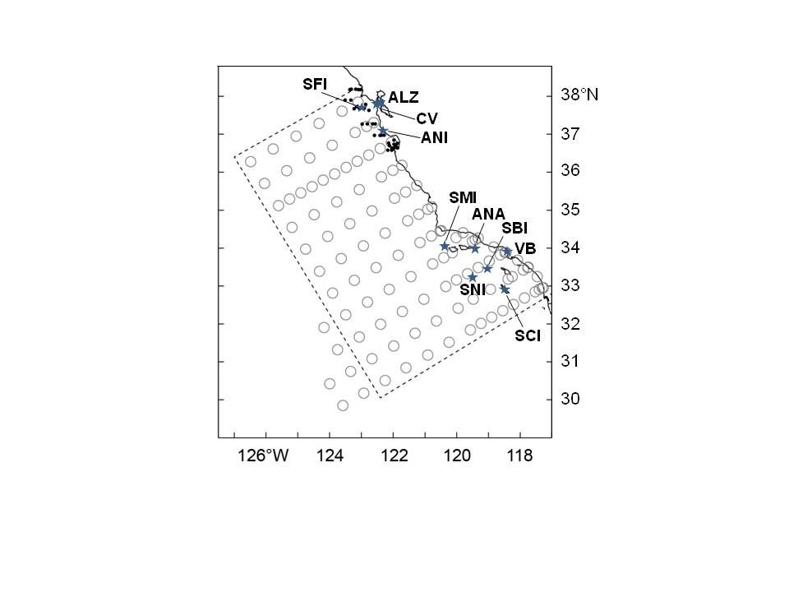

**Figure 1.** CCE study area spanning San Diego to Pt. Reyes. Forage data were obtained from JRS stations which are indicated as small black solid dots and CalCOFI stations which are indicated as blue circles; CalCOFI data were used from within the dotted box (see text for details). Predator sampling locations are shown as blue stars and include SFI = SE Farallon Island, ALZ = Alcatraz Island, CV = Central Valley (Chinook ocean entry point), ANI = Año Nuevo Island, SI = San Miguel Island, ANA = Anacapa Island, SBI = Santa Barbara Island, VB = Venice Beach, SNI = San Nicolas Island, SCI = San Clemente Island.

**Figure 2.** Predator threshold models for a) seabirds, b) sea lions, and c) salmon, relative to forage fish prey abundance in the central and southern CCE.

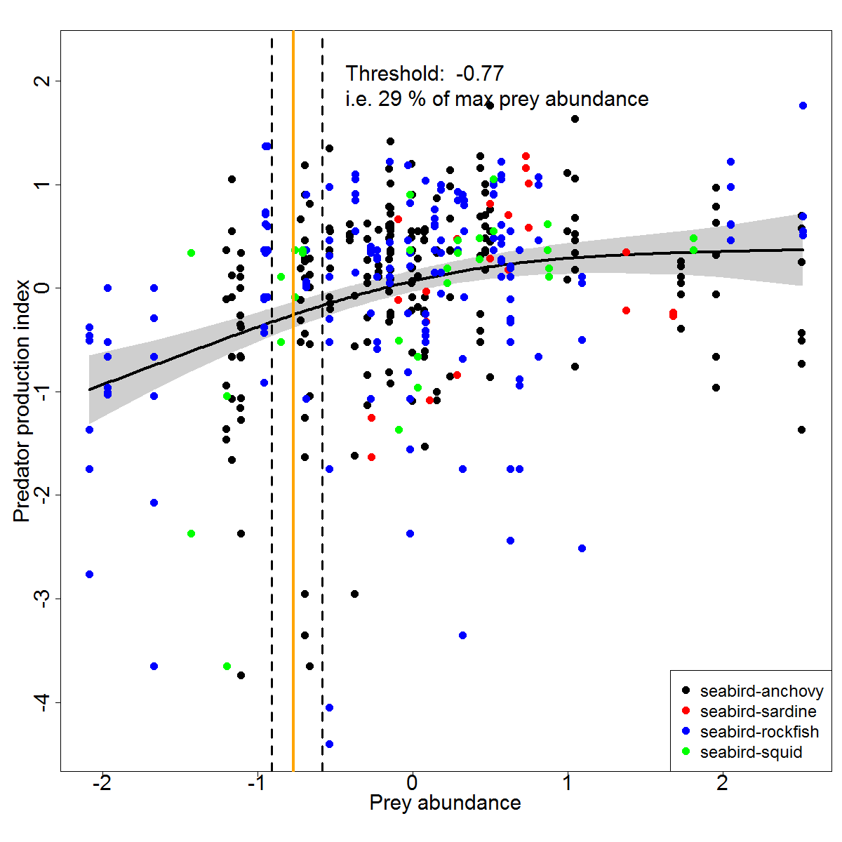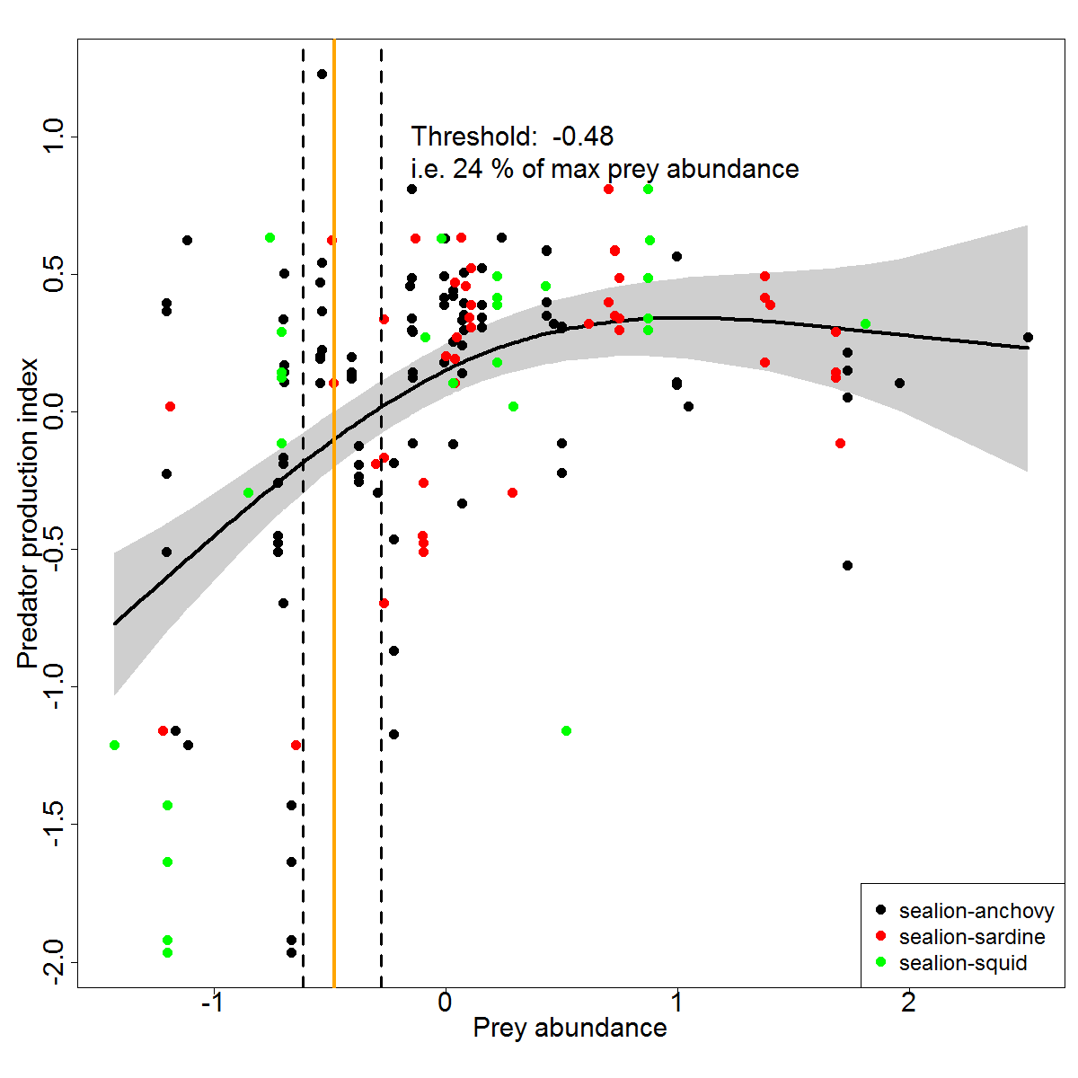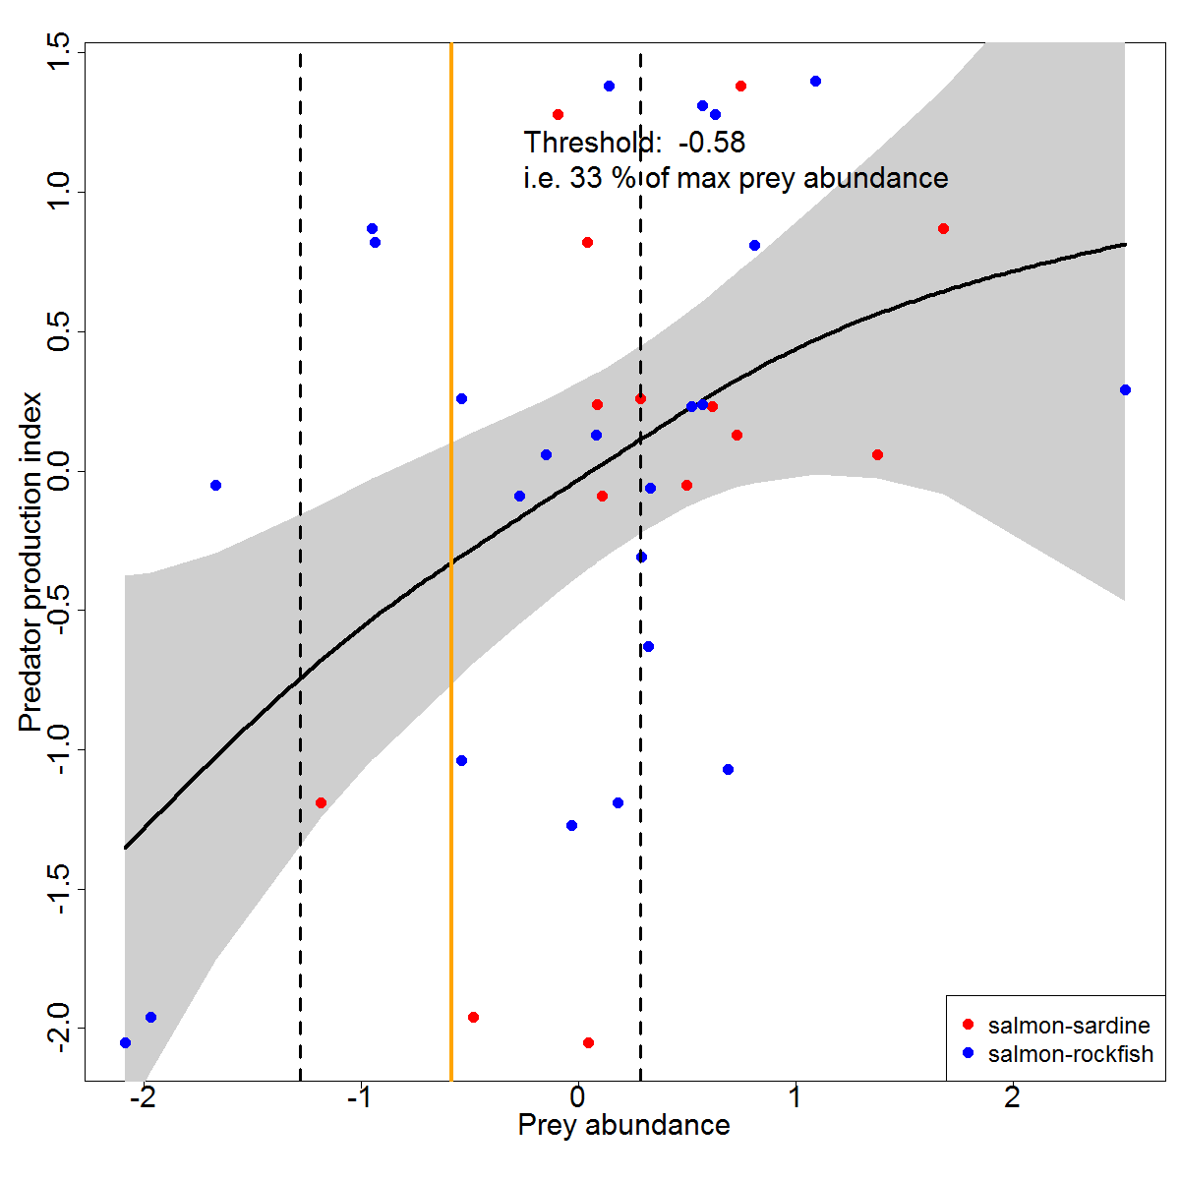

**Figure 3.** Models of marine vertebrate predator indices of productivity with a) rockfish, b) anchovy, c) market squid, and d) sardine prey indices in the central and southern CCE*.*

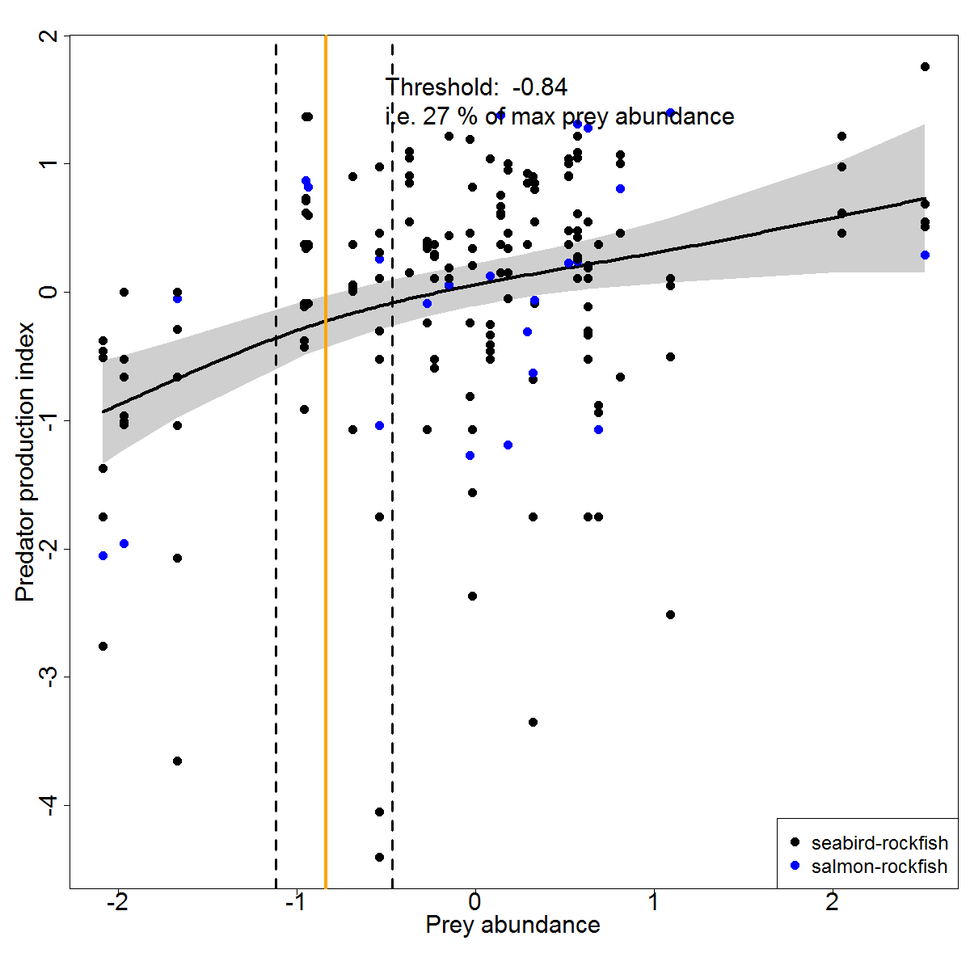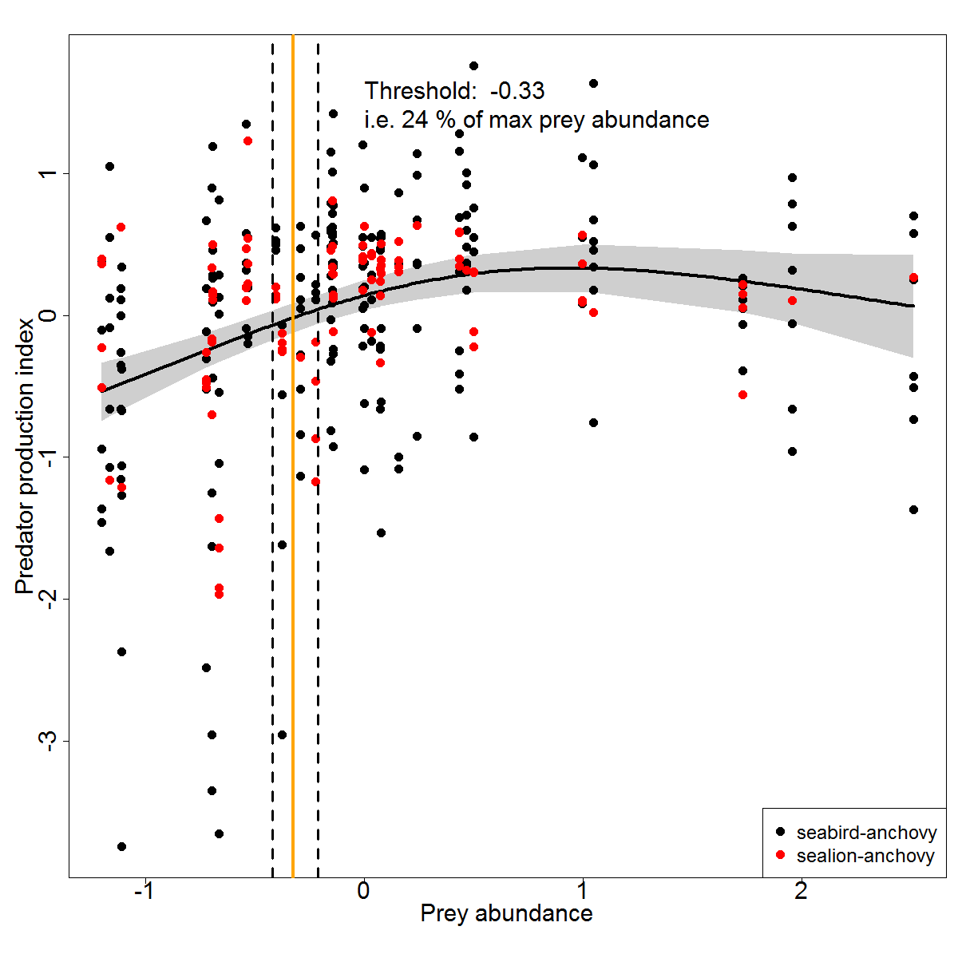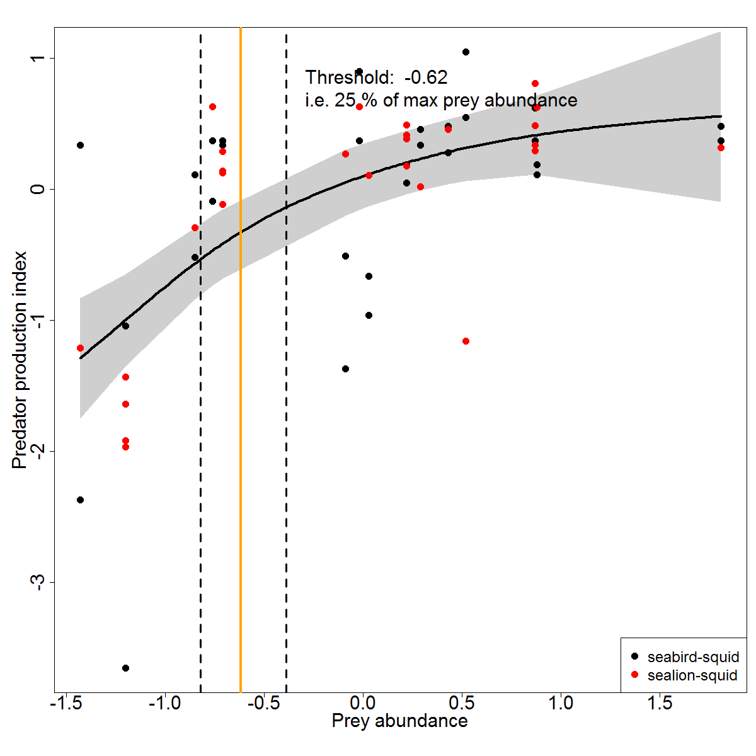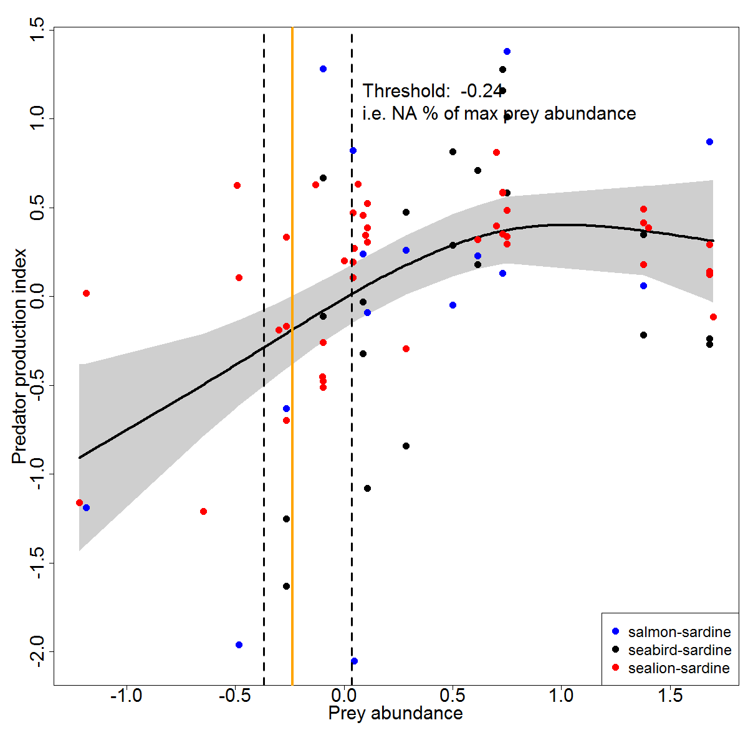

**Figure 4.** Models of productivity indices of all predator taxa relative to forage fish prey abundance in the a) central and b) southern CCE.

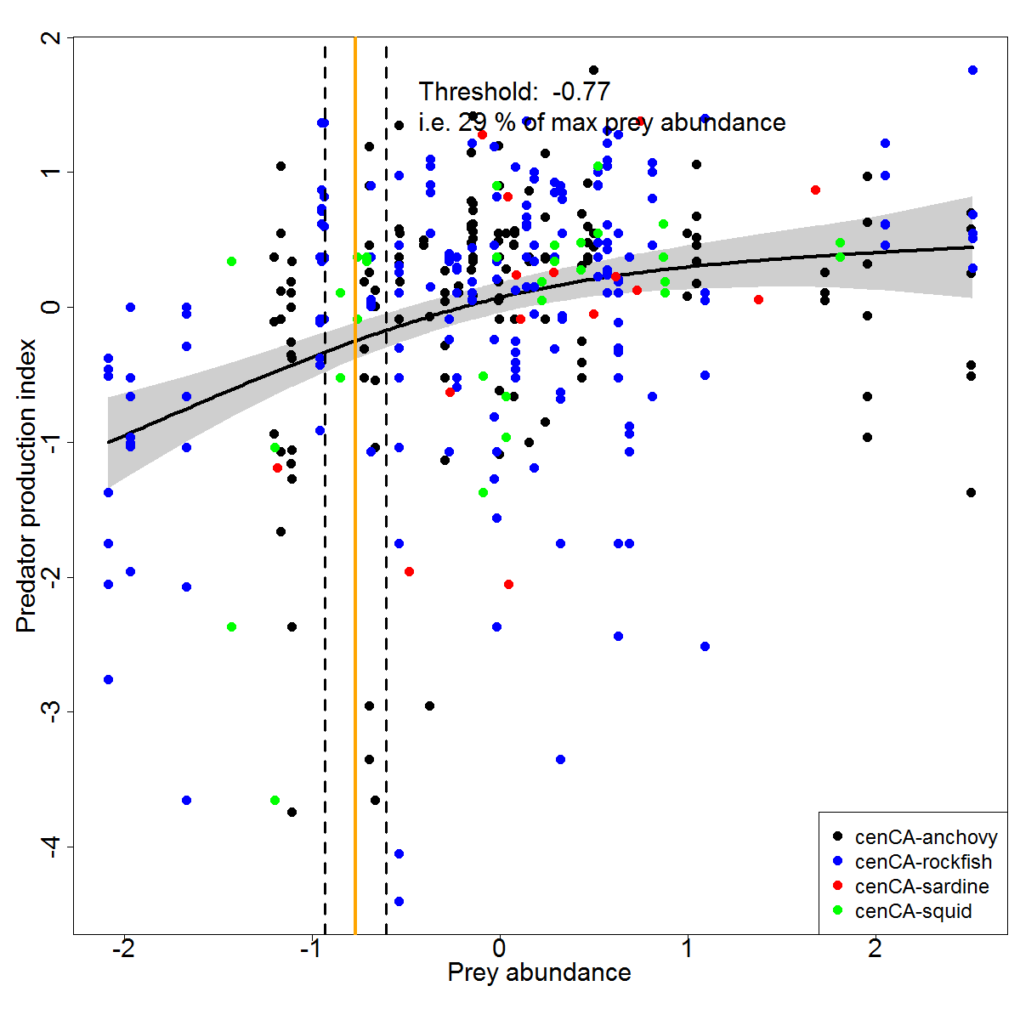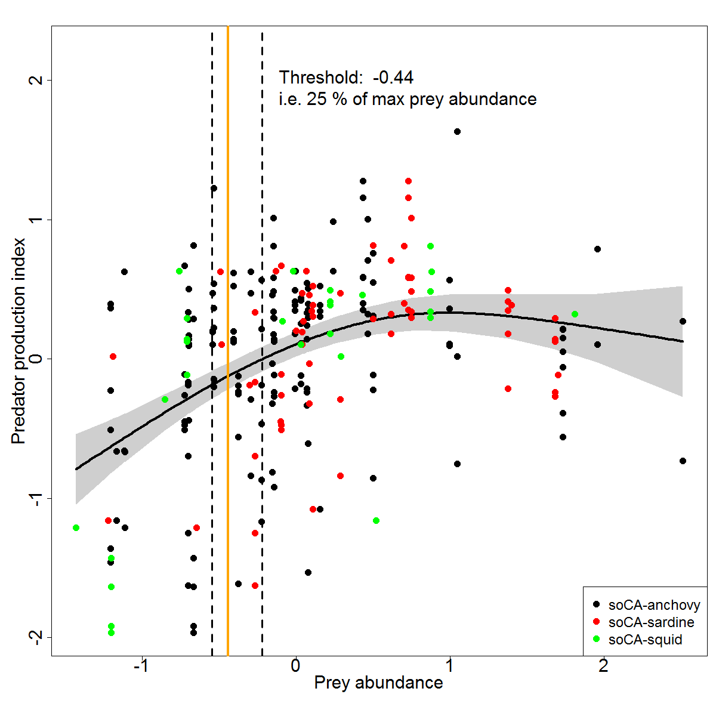

**Figure 5.** a) Overall model of seabird, sea lion, and salmon predator indices of productivity with rockfish, anchovy, market squid, and sardine prey indices in the central and southern CCE. b) Change in variance across the range of normalized prey abundance.

